Lecture 9 - Exercises with Solutions

Question 1: Electromagnetic radiation and matter

a) UV/Vis spectrometry relies on electromagnetic radiation with energy that corresponds to:
- Transitions between vibrational levels of chemical bonds
- Interference with nuclear energy levels
- Transitions between electron energy levels
- Molecular diffusion states

b) Select a statement that is false:
- Differential scanning fluorimetry is a spectroscopic method
- Visible light has higher energy compared to microwave radiation
- Radio-frequent radiation is used in resonance experiments
- UV spectrum is reduced with the content of conjugated double bonds

c) Circular dichroism is based on:
- Differential scattering of left- and right- polarized UV radiation
- Differential absorption of non-polarized UV radiation
- Differential absorption of left- and right- polarized UV radiation
- Dynamic motion (vibrations) of secondary structure element

d) Select a statement that is true:
- Chromophores display stronger UV/Vis absorbance compared to fluorophores
- Fluorophores have larger optically-active groups compared to chromophores
- Fluorophores emit radiation of lower energy compared to the absorbed radiation.
- Fluorophores emit radiation of lower wavelength compared to the absorbed radiation.

e) Stokes-Einstein equation is used in which method:
- Circular dichroism
- Differential Scanning Fluorimetry
- X-ray crystallography
- Dynamic light scattering

f) To achieve resonance in experiments like NMR, it is necessary:
- That the UV light and the external magnetic field are aligned in 3D space.
- That the difference between vibrational energy levels is equal in energy to the radiation used for excitation
- That the difference in energy levels created by external field is equal in energy to the radiation that is used for excitation.
- That the power of external magnetic field fluctuates with the same frequency as that of radio-frequent radiation.

Question 2: Select a biophysical method for your experiments

You produced a small bacterial protein (~10kDa) that has not been characterized previously. After performing extensive chromatographic purification step you wish to learn more about this protein. Select the biophysical methods from lectures 8 and 9 that you can use to measure the below-mentioned properties:

Inspect protein purity | SDS-PAGE
Determination of the molecule radius in native state | DLS
Determine the content of secondary structure elements | CD, FT-IR
Determination of molecular weight in denatured state | SDS-PAGE
Measure concentration | UV Spectrometry
Measure protein stability to thermal denaturation | CD, DSF, FT-IR
Solve atomic structures | NMR, X-ray crystallography
Study protein aggregation | DLS, cryoEM
Protein localization inside the cell | Fluorescent microscopy

The method options are:
- Dynamic Light Scattering (DLS)
- Sodium-dodecyl-sulfate polyacrylamide gel electrophoresis (SDS-PAGE)
- Circular dichroism (CD)
- UV spectrometry
- Differential Scanning Fluorimetry (DSF)
- Fluorescent microscopy
- Cryo-electron microscopy (cryoEM)
- Nuclear Magnetic Resonance (NMR)
- X-ray crystallography
- Fourier-Transform Infrared Spectroscopy (FT-IR)
Question 3: UV absorbance

a) Below are structures of several fatty acids containing different content of double-bonds, resulting in different minimal energy difference between π and π* levels. Order the molecules based on the location of their maximum UV absorbance wavelength (λ_{max}), from highest to lowest.

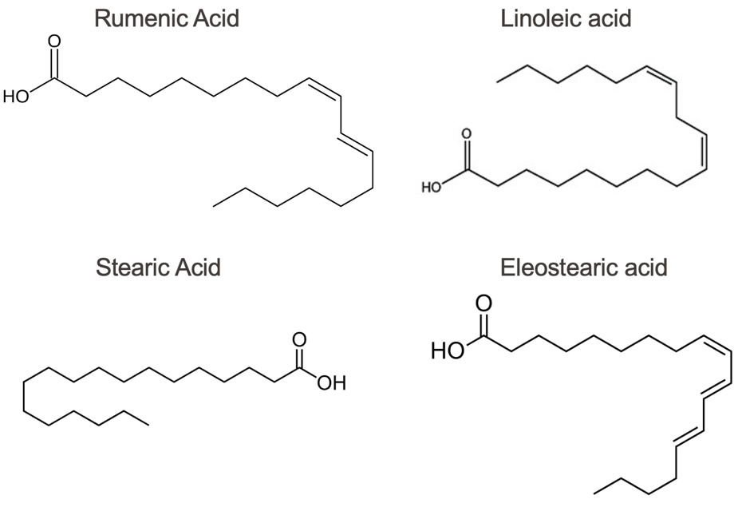

b) Below are the sequences of 3 different short proteins (peptides). Based on the content of UV-active amino acids in each peptide, can you rank them based on the expected extinction coefficient at 280nm (from highest to lowest)?
Peptide M: MSTRKRVVNTSPLGNEDPKNYQMILAPRESNQGNKILSSGQEDPRTN
Peptide N: MTGFTTVNGTWADTIEGKQGRSDGDSYILSSASGSDRTYESNMPSL
Peptide O: MNGRGAGALMYRSDKDAKNGYLANVDAKDLVKKENGAASKLMIPNT

c) You wish to determine the concentration of Protein X in aqueous buffer. Its’ molecular weight is 67kDa and the molar extinction coefficient at 280nm wavelength (ε₂₈₀) is 43,824 L/(mol*cm). Using a cuvette with a light path (l) of 1cm, you measured the absorbance at 280nm to be 3.5. Based on these values can you determine the molar concentration of this sample (mol/L). What is the mass concentration (g/L)?

Answer:

a) The greater the number of conjugated double bonds -> the higher the λ_{max}
- Eleostearic acid - λ_{max} = ~280nm (3 conjugated double bonds)
- Rumenic acid - λ_{max} = ~235nm (2 conjugated double bonds)
- Linoleic acid - λ_{max} = ~215nm (double bonds are separated by 2 single bonds, resulting in weak conjugation)
- Stearic acid - λ_{max} = ~200nm (no double bonds)

b) Given that F, H and C are absent from the polypeptide sequences, W and Y are the only amino acids that would determine the extinction coefficient. The greater the number of these amino-acids -> The higher the extinction coefficient. So, the correct order is:
- Peptide N: 1 W + 2 Y
- Peptide O: 2 Y
- Peptide M: 1 Y

c) First, we use Lambert-Beer’s law to determine the molar concentration (C_{M}):
A = ε₂₈₀ * l * C

C_{M} = A / (ε₂₈₀ * l) = 3.5 / (43,824 * 1) mol/L = 79.9 * 10⁻⁶ mol/L = 79.9µM

Then we use this value together with the molecular weight information to calculate the mass concentration (C_{g}):

MW = 67kDa = 67’000 g/mol

C_{g} = MW * C_{M} = 67’000 g/mol * 79.9*10⁻⁶ mol/L = 5.35 g/L

Question 4: Circular dichroism

You expressed and purified a bacterial carbohydrate-binding protein Z. This protein can detect galactose and switch on downstream signaling pathways to metabolize this sugar. You are interested in uncovering the molecular processes that regulate this signaling and discover a way to exploit it for therapeutic purposes.

a) You performed circular dichroism (CD) on protein Z in the presence and absence of the ligand (at ~25˚C). You obtain the results below that show significant differences in CD spectra. Please describe what type of an effect the ligand has on protein? What type of change in secondary structure content has occurred?
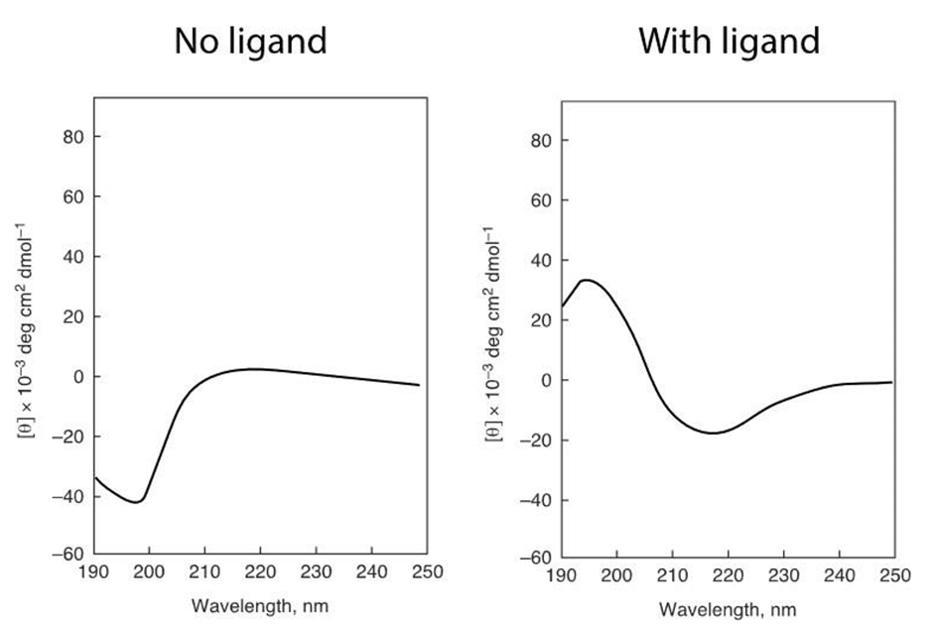

b) You wanted to measure the thermal stability of protein Z in the presence of the ligand using CD and you obtain the graph shown below. Can you estimate the Tm value from this plot? What would the raw CD curve (ellipticity vs wavelength) look like at temperatures >95˚C?
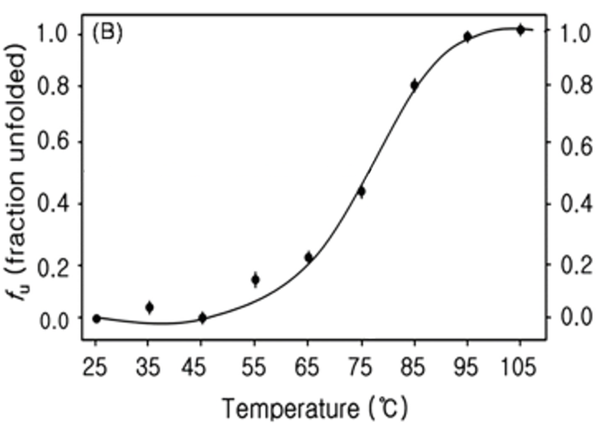

c) You are interested in developing a new antibiotic candidate that will inhibit this critical galactose detection mechanism and block downstream metabolism. You have a library of potential compounds to screen from. How would you setup the CD assay to determine which of these candidate compounds can block the activity of this protein?

Answer:
a) The ligand causes protein Z to take on a structured 3D state, converting from random coil (unstructured) architecture into a beta-sheet based architecture.
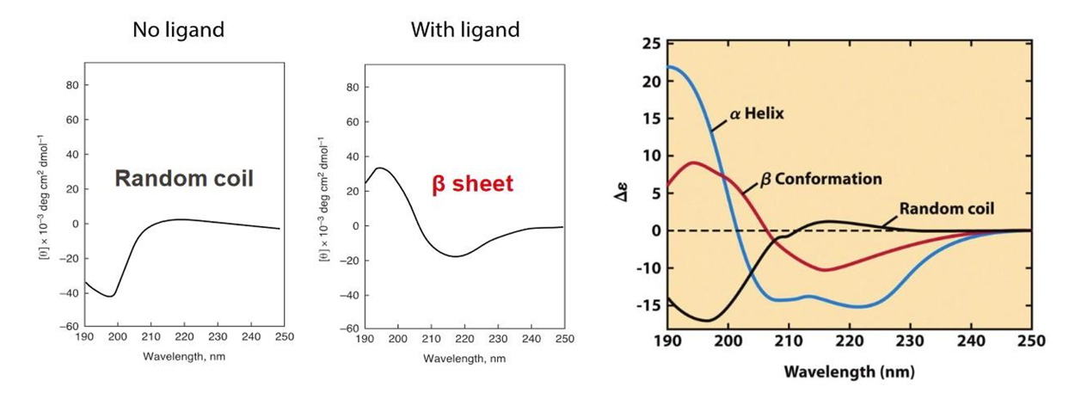
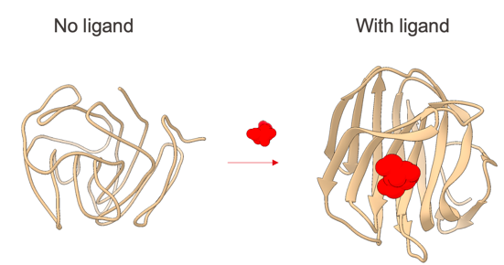

b) The Tm value is calculated as the temperature where 50% of the protein (0.5 fraction) is in the unfolded state. Therefore, Tm estimated based on this curve is ~76-77˚C.
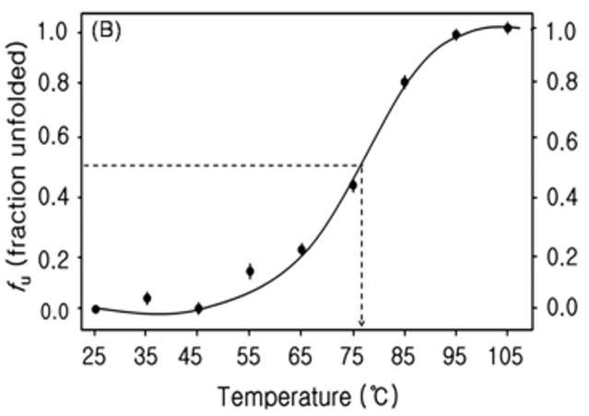
At temperatures >95˚C most of protein Z will be in unfolded state and the raw CD spectra will show random-coil assembly, very similar to the one that the protein Z has in the ligand-free state shown in panel a) of this question.

c) While CD is a relatively costly experiment in terms of sample requirements and throughput, it can certainly be used to evaluate inhibition by compounds. In this case you can screen by adding the candidate compounds with protein Z and then adding galactose to the mix. By recording the CD spectra (at 25˚C) you will be able to evaluate if the compound prevents transition from unfolded (random-coil) to the active beta-sheet state. If the compound really inhibits the process, the transition should not take place and all protein will stay in random coil state. Several other possibilities can also take place.
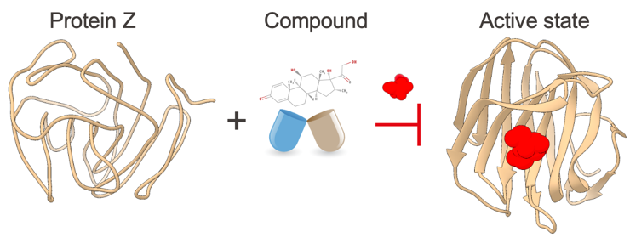

Question 5: Light Scattering

Dynamic and multi-angle light scattering methods are particularly useful in pharmaceutical industry for monitoring the quality and homogeneity of different therapeutic formulations.

a) Below you will see a DLS size-distribution curve of a monoclonal antibody cocktail after storage at room temperature for different periods of time. Can you infer what could be happening to the sample over time? What would be the max storage time under these conditions to assure the sample is still effective for therapeutic use?
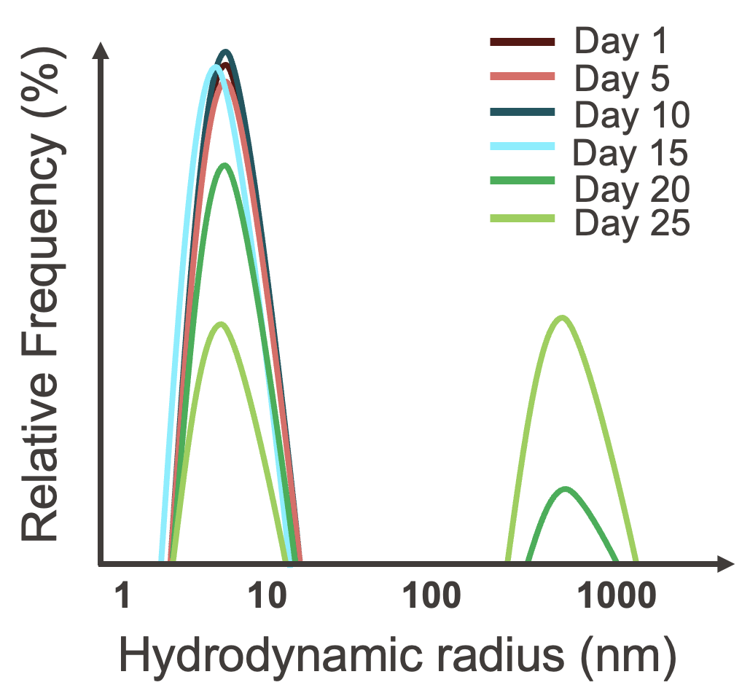

b) You propose that one way to preserve the sample is to store it at lower temperatures (e.g., 4˚C). The viscosity of aqueous solutions is 2x higher under these conditions. How will this affect the diffusion coefficient of the monoclonal antibody? What about the hydrodynamic radius? Qualitative descriptions are sufficient.

c) Calculate the r_{h} for this monoclonal antibody in storage solution at 4˚C (T=277K). The diffusion coefficient (D) is 2.1*10⁻¹¹m²/s and the viscosity (η) of the storage solution at this temperature is 1.6*10⁻³ Pa*s (=J*s/m³). Assume that the Boltzmann constant (k_{b}) is 1.38*10⁻²³ J/K, and π=3.14

Answers:
a) The monoclonal antibody sample is aggregating over time which is reflected by the formation of a second species with diameter between 500-1000nm. The last time point at which no aggregation is observed is at Day 15. Therefore, the max storage time without any visible signs of issues (at least by DLS) is 15 days.

b) Consider Stokes-Einstein equation:
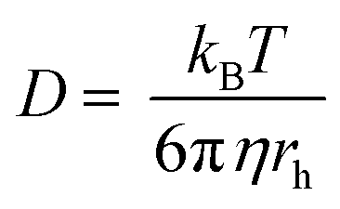
Given that the radius of hydration is the property of a given protein dependent on its size, shape and density, the change in temperature will have minimal influence (if any) on this feature. It can still happen that temperature triggers a conformational change that would consequently change the r_{h}, but this is rare.
However, due to the two-fold increase in viscosity and a reduction in temperature, the net effect will be a decrease in the diffusion coefficient. This is relatively intuitive since (i) lower temperature will reduce the speed at which particles move in solution (less thermal energy), and (ii) increased viscosity will result in greater liquid resistance to particle movement. Altogether, both effects add to reduced diffusion.

c) If we solve Stokes-Einstein equation for r_{h} we get:

$$rh=\frac{kB*T}{6*π*η*D}$$
By plugging in the numbers, we get:

r_{h} = (1.38*10⁻²³ J/K * 277 K) / (6 * 3.14 * 1.6*10⁻³ Js/m3 * 2.1 *10⁻¹¹ m²/s)

rh = 382.3*10⁻²³ / 63.3*10⁻¹⁴ m = 6.0*10⁻⁹m = 6.0nm
Question 6: Protein dynamics

Aggregation of certain cellular proteins (e.g., alpha-synuclein) is believed to be the primary causative factor of neurodegenerative disorders. You discovered one protein of only 80 amino-acids (MW = 9.5kDa) that resembles alpha-synuclein, and you suspect that it may undergo similar aggregation process upon triggering with chemical stimuli (e.g., ligand or low pH).

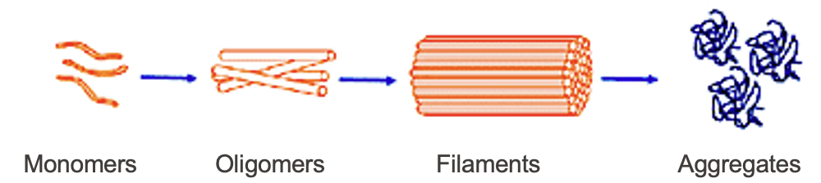

a) Which methods would you use to determine if the protein is structured or disordered before chemical induction?

b) After getting a better understanding of the protein in its monomeric form, you now wish to study the aggregation process. You can trigger aggregating by lowering the pH of the buffer which allows to control the start of the process. Which method can you apply to study the size of the oligomers and aggregates at different time points?

c) In alpha-synuclein the transition to fully aggregated state proceeds through several intermediates (e.g., oligomers, filaments) which form regular b-sheet-enriched assembly. The transition usually takes a few hours. Which method could you use to monitor this process over time?

d) The previous step provides important inputs that allow you to stop the reaction at a specific point and obtain intermediate products of the aggregation process (i.e., oligomers and filaments). To obtain better understanding of the reaction progress you decide to perform structural characterization of starting, intermediate and final protein states. Which methods would you select for determination of atomic structures of the (i) monomer, (ii) oligomers, (iii) filaments and (iv) final aggregates?

Answers:
a) You can use several different methods (including structural biology approaches), but CD or FT-IR would be the quickest/simplest ways to determine if the protein has any secondary structure elements (structured) or if it is all random coil (unstructured/disordered).

b) You can use dynamic light scattering (DLS) to determine the hydrodynamic radius of molecular clusters that are formed during the aggregation process.

c) Both CD and FT-IR can provide information on changes in secondary structure arrangement of molecules. In both cases, only seconds/minutes are needed to collect a full spectrum so you can closely monitor the reaction as it progresses

d) The proposed methods in each case are:
(i) Monomer: Given the small size and potential flexibility, NMR would be the method of choice here. But X-ray crystallography can also be used. The monomeric state is too small for cryo-electron microscopy.
(ii) Oligomers: In the photo we see at least 4 molecules bundled together, which would make the MW 38kDa. At this point, NMR would be a possible option but due to the increase in MW, the preference should be given to X-ray crystallography. The oligomeric complex is still too small for cryo-electron microscopy
(iii) Filaments: Filaments would be definitely too big for analysis by NMR, so the preference here should be given to X-ray crystallography and cryo-electron microscopy.
(iv) Aggregates: They are very large in size and heterogeneous in composition. The heterogeneity makes them unsuitable for crystallography (not possible to assemble crystals), while the size makes them not suitable for NMR. The only option is cryo-electron microscopy since it does not have a high molecular weight limit. But given the diversity of possible assemblies even electron microscopy may not be able to properly assess these proteins.

There is a branch of electron microscopy called cryo-electron tomography (cryoET) that could help with this challenge. See Prof. Henning Stahlberg’s work for more details:

https://www.nature.com/articles/s41593-019-0423-2
https://pmc.ncbi.nlm.nih.gov/articles/PMC11531854/

